**LAB EXPERIMENT 2**

**Aim**

To design and implement a hybrid network of star and tree topologies using routers, switches, and PCs. To configure the router to act as a DHCP server for dynamic IP allocation and to configure nodes with both dynamic and static IP addresses. Finally, to create and configure a shared folder accessible by all users on the created network.

**Apparatus Required**

* **Hardware:**
  + Router (e.g., TP-Link, D-Link)
  + Switches (e.g., 8-port unmanaged switch)
  + n x Desktop Computers (e.g., 4-6 PCs)
  + Cat6 Ethernet Cables
  + Power Cords
* **Software:**
  + Windows/MacOS Operating System on all PCs

**Procedure:**

First, a hybrid topology was physically created. A central switch was connected to the router's LAN port using a Cat6 cable, forming a star topology with the initially connected PCs. Another switch was then connected to a port on the central switch, creating a tree branch to connect additional nodes.

Next, the router was configured by accessing its admin interface via a web browser (e.g., at $192.168.1.1$). The DHCP server was enabled, and an IP address pool (e.g., $192.168.1.100 - 192.168.1.200$) was set for dynamic allocation. Most PCs automatically received an IP from this range**.**

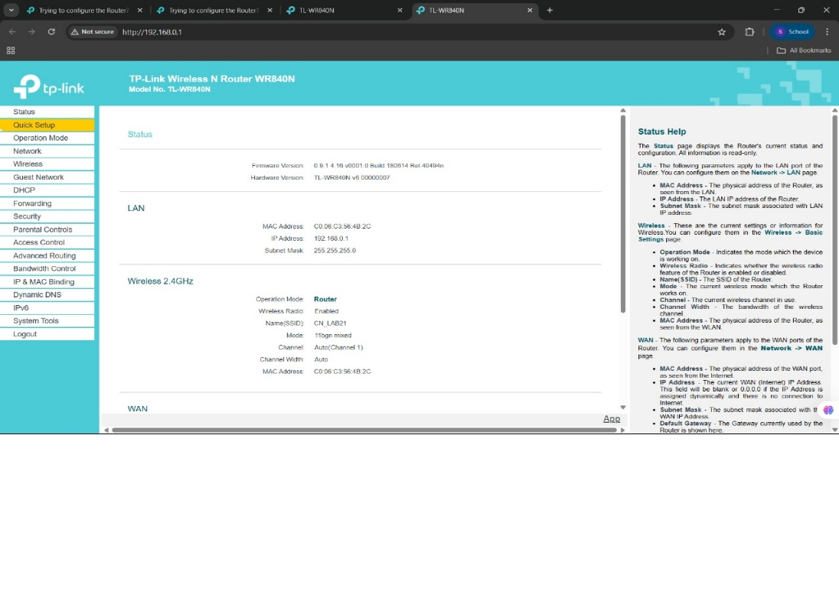

For manual configuration, one PC's network adapter settings were opened. A static IP address outside the DHCP range (e.g., $192.168.1.50$), a subnet mask ($255.255.255.0$), and the router's IP as the default gateway were entered. Connectivity for all nodes was verified using the ping command.

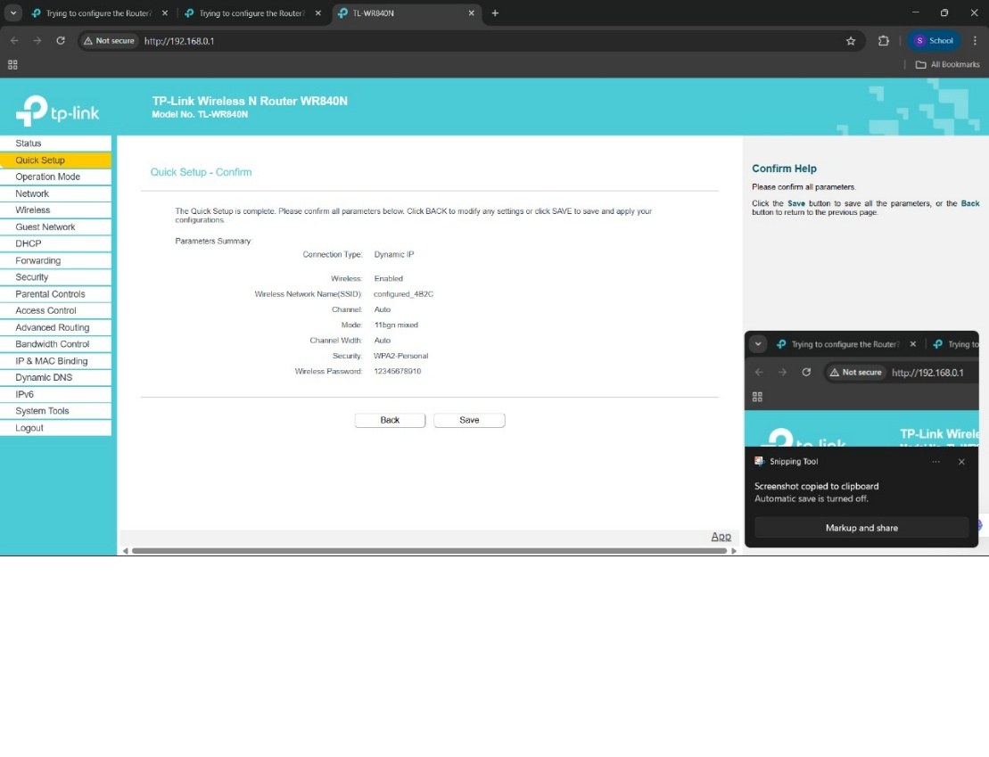

Finally, on one PC, a new folder was created. By right-clicking the folder, navigating to Properties > Sharing > Advanced Sharing, permissions were set to allow 'Everyone' to read and write. A text file named with the registration number was created and placed in this shared folder, making it accessible to all users on the network.

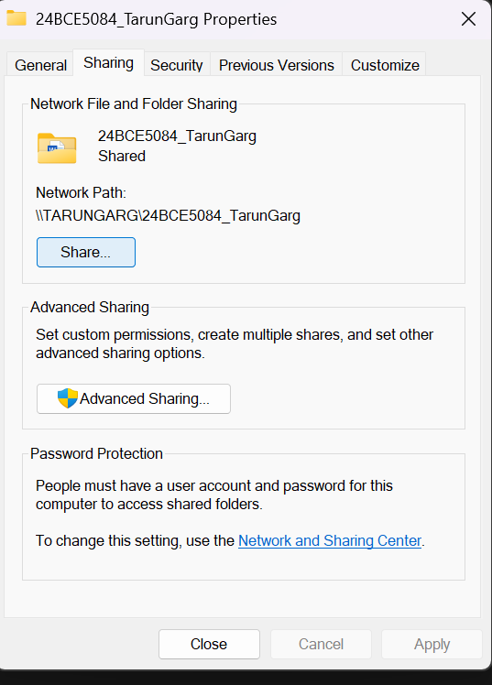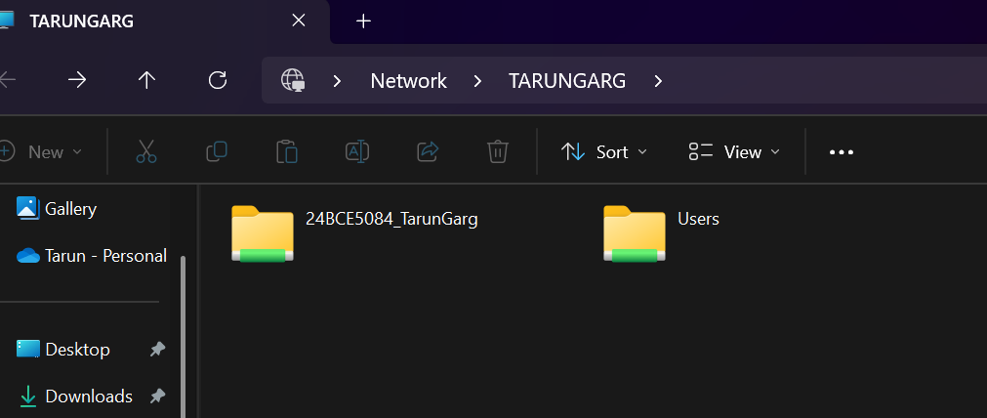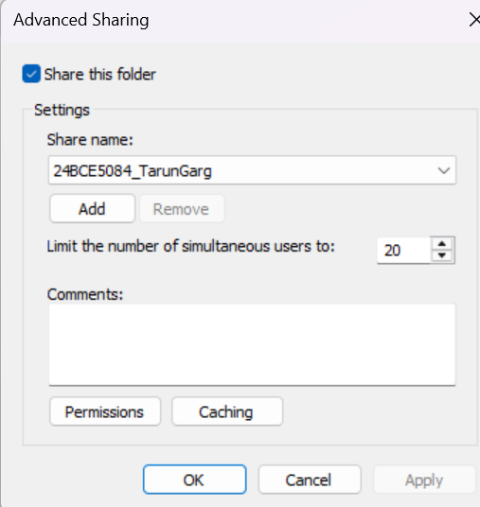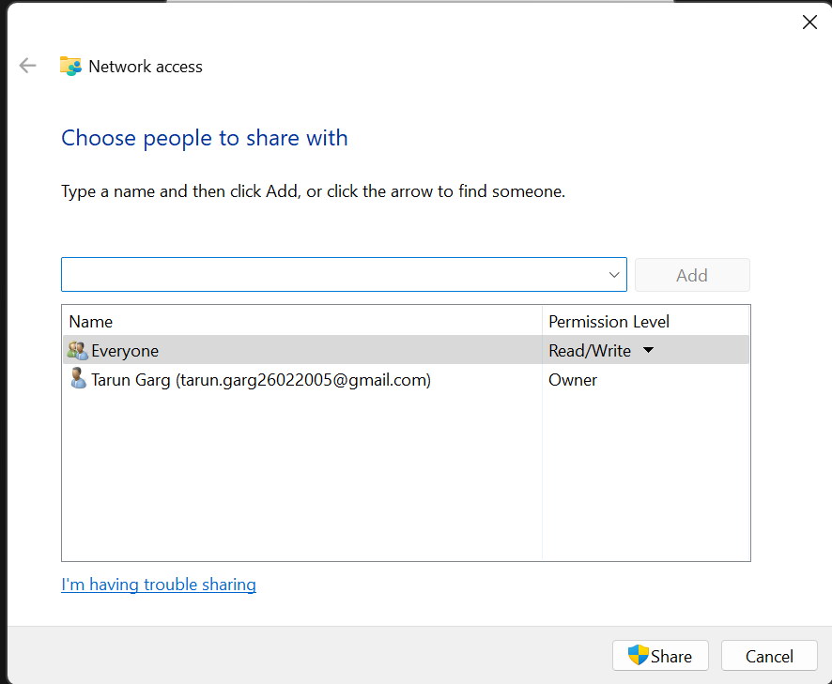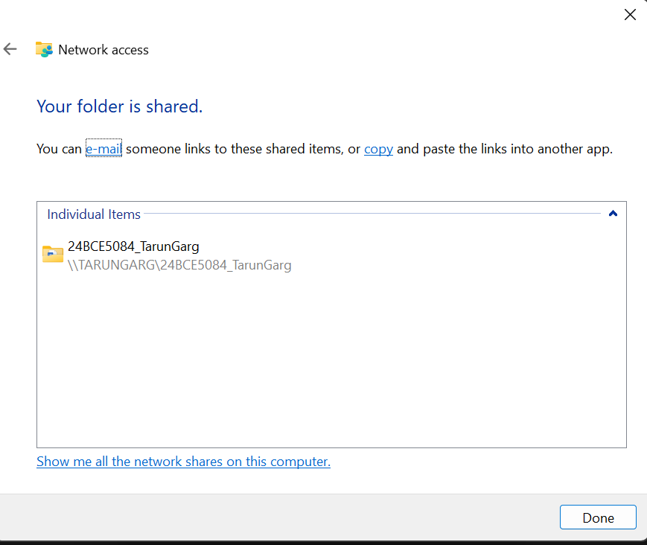

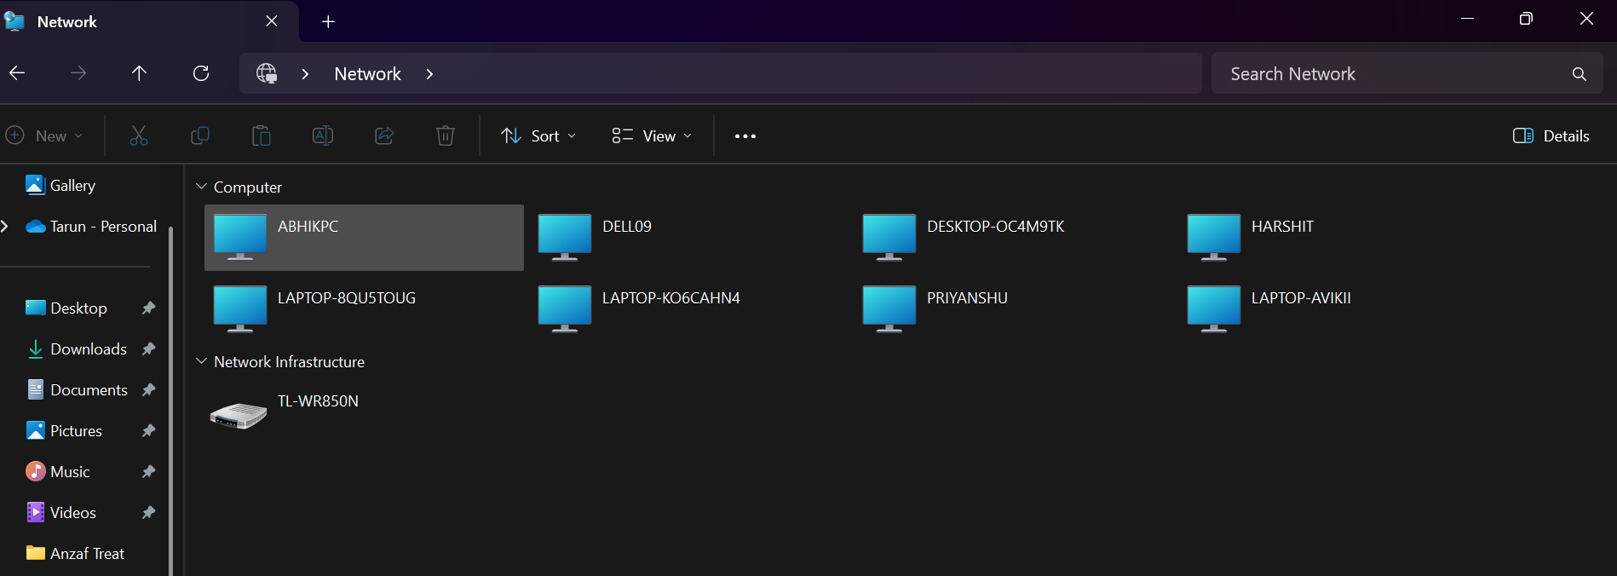

**Result and Conclusion**

A hybrid star-tree network was successfully created and configured. The router was configured as a DHCP server, dynamically assigning IP addresses to designated nodes, while other nodes were configured with static IPs. All nodes in the network were able to communicate with each other, verified using the ping utility.

Furthermore, a folder was successfully shared from one host, and its permissions were set to allow access for all users on the network. The shared folder and its contents were successfully accessed from a remote client PC, demonstrating a functional file-sharing environment. This experiment provided practical experience in physical network setup, IP address management (DHCP vs. Static), and network resource sharing.

**NAME - TARUN GARG**

**REGISTRATION NUMBER - 24BCE5084**